Merry Christmas everyone!
As always, thank you for being willing to be a part of Shamgar Ministries. Our last newsletter stated the five specific areas that we believe that God is leading us to minister in. Those ministries are: 1) Community Outreach 2) Celebrate Recovery 3) Chaplain Ministry 4) Construction 5) Church. Please pray for all of these ministries as we work to grow them.
We need each of you to pray earnestly for the "Celebrate Recovery" ministry and the Chaplain ministry. These are the two that we are working to get off the ground in the very near future. Let me offer a word of clarification and explanation on these ministries.
"CELEBRATE RECOVERY" - This ministry reaches out to addicts and their families. We will begin with classes for drug addicts and alcoholics along with a codependency class. Celebrate Recovery is a Christ-centered Bible based program. Southside Baptist Church in Warner Robins has used this program for several years and is helping us get started. Celebrate Recovery will meet once a week and will include a worship service, small groups and hopefully a fellowship meal. The meetings will take place at The Hangar (old Fred's building). There is a lot of ground work left to do and we are still a couple of months away from being able to begin the meetings. If you believe that this ministry is one that God would have you serve in please contact me as soon as possible either in person or by e-mail or phone. Those who would serve as group leaders must be recovering addicts with at least one year of clean time. Servants, any Christian that loves the Lord and wants to serve, are needed in other areas such as: music, child care, food service, greeters and other support staff.
CHAPLAIN MINISTRY - Our Chaplain ministry is going to start in the Bleckley County jail. This will require teams of 2-4 people. We need at least one lady on each team. The number of servants will dictate the number of teams which will determine the frequency of prison visits. We will be ministering to both female and male inmates. At this time our plans are to minister in the morning once a week or maybe once every two weeks. Again, if this is a ministry where you believe God wants you to serve, please contact us so we can discuss it with you.
A quick update on what’s been happening through your gifts. We have almost completed the work for the renovations at Promise of Hope. Just a few odds and ends left to finish there. The first weekend in December we were able to participate with Mountain Outreach at Cumberland University in Williamsburg, Kentucky in distributing new toys, some food, and clothing to 435 needy children and their families. We were also able to purchase some Bibles for the FCA in Bleckley County. We’ve done a few small repair jobs for people and helped with the remodeling of the Hangar. We continue to minister at Rhine Baptist Church as interim. We have been in a lot of necessary meetings this last month laying the ground work for the ministries in the jail and Celebrate Recovery. We are very excited about the work God is preparing and hope all of you that feel led will cover it in prayer and join us. We always covet your prayers for God’s will for Shamgar.
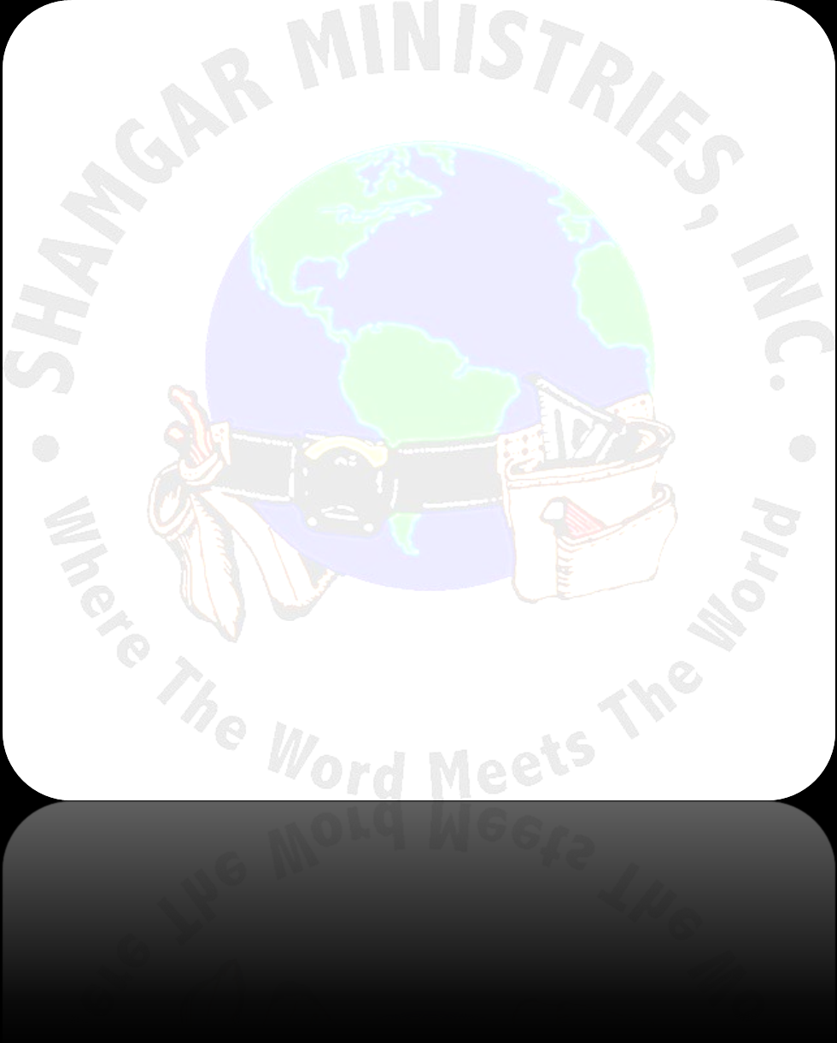
In His Service,
Rusty and Denise

